Assignment: One-Point Perspective
Part 1
1. | Place paper in landscape view.
2. | Draw a horizontal line with your ruler lengthwise (extremely lightly) Note: All of my guide lines will be in the form of a dashed line. This is called your horizon line, where the land meets the sky.
3. | Put a dot in the middle of this line. This is called the vanishing point. All receding lines point to this dot. These receding lines are called orthogonal lines. | 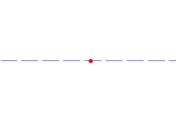
4. | On the left side of your paper, draw three squares. One above the horizon line, one below, and one underneath. | 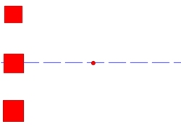
5. | Rule #1: You never draw a orthanginal line that goes through an object (unless that object is transparent). So from each corner of the rectangles, you're going to draw a guide line leading to the vanishing point. | 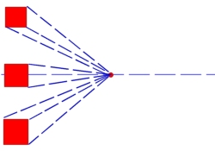
6. | Next, you take your ruler and match it up to one of the sides of your boxes. | 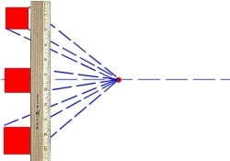
7. | Slide it back along the lines and make another line. | 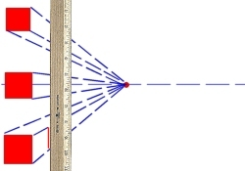
8. | Do the same with the other side. | 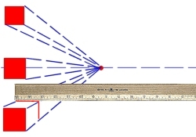
9. | Darken your guide lines between the two sets of lines. | 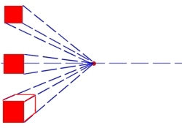
10. | Repeat with the other squares. Try to make one square really long and the other really short. Notice that you'll only see one side of the square that is on the horizon line. | 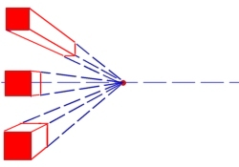
11. | Now erase your guide lines. | 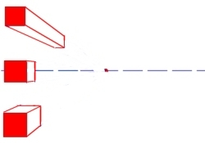
12. | To find the center of these shapes, you draw an X as shown. You might need to find the center if you were drawing windows or making letters. | 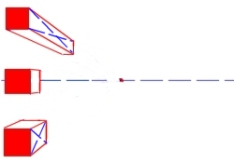
13. | To make signs with letters on them, you need to make sure they are in perspective also. The letters should get smaller as they go back. | 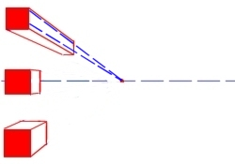
14. | Make sure all of your vertical lines (like on my R and T) are straight up and down. Your horizontal lines should be in perspective (pointed at your vanishing point). Like the A and top of the T. | 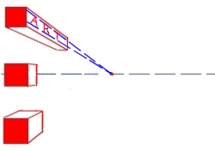
15. | Practice making creative boxes, such as cereal boxes, dice, trains, presents, etc. See what overlapping can do. Make 5 boxes above the horizon line, 5 below. and 5 on the horizon line. | 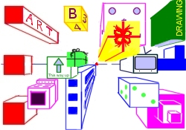

Part 2
Assignment 2: On another piece of paper, after drawing your horizon line and vanishing point, I'd like you to draw each of the following shapes 3 times (one above the horizon line, one on, and one below).
1. | Draw a circle above, on, and below the horizon line. | 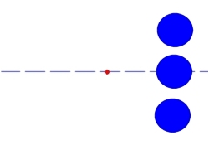
2. | With rounded objects, I always rest one part of my ruler on the vanishing point and then slide the ruler down until it just touches the rounded object. Then you draw your line from here. | 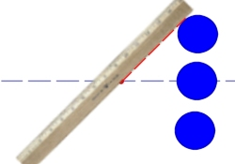
3. | After you do this with both sides, you then make a parallel shape as shown. The shape should mimic exactly what the original line is doing. I sometimes go over the original line a couple of times with my pencil to get the feel of the shape before doing the second line. | 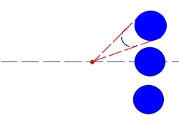
4. | Fill in the guide lines between the two lines then erase your guide lines. | 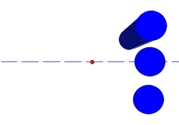
5. | Finish the other two shapes. | 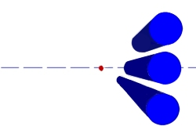
6. | Draw a triangle above, on, and below the horizon line. | 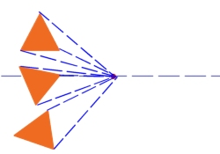
7. | Line up your ruler with one of the sides. | 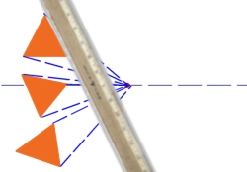
8. | Slide it back along the angled lines so that it's perfectly parallel with your original line. | 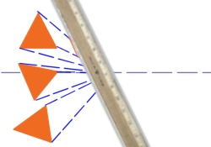
9. | Connect the guide lines between the lines and fill in your shape. Finish the other two. | 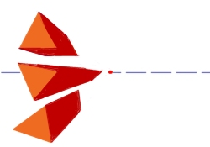
10. | Geometric shape (shape with sharp edges) | 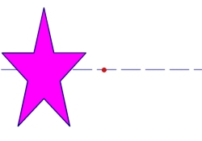
11. | Connect each sharp edge to the vanishing point. Notice that orthogonal lines don't go through your shape (unless it's a transparent shape). | 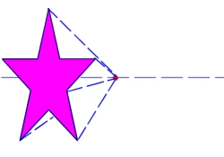
12. | Just like the triangle, you find your edge. | 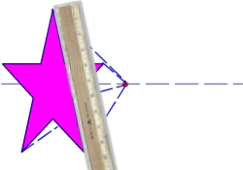
13. | Slide it back and make your line. | 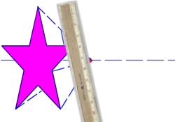
14. | Connect the two sets of lines. | 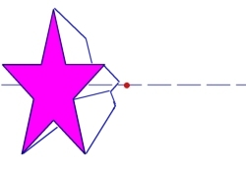
15. | Floral shape (shape with rounded edges) | 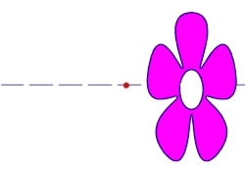
16. | I treat floral shapes just like circles. Using your vanishing point, pivot your ruler until it just brushes the side of your shape. Draw your orthogonal line from this point. | 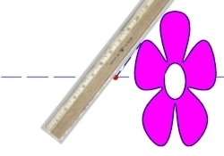
17. | Continue with the other sides. | 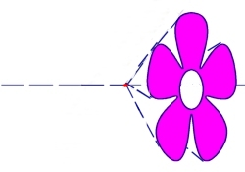
18. | Mimic the shape of the object. | 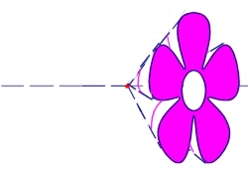
19. | Shade if you wish. | 